Zero Trust Network Access (ZTNA) with Zscaler: Securing User-to-Application Connectivity.

College Name: Nandha arts and science college.
College Code: BRU4J

Team ID: SWTID-2026-3132

Team Members:
Team Leader Name: ANISH M
Email: anish19112004@gmail.com
Team Member: VIGNESH G
Email: vvigneshg938@gmail.com
Team Member: BOOPATHI P
Email: boopathibathi4059@gmail.com
Team Member: MOHAMMED IQLAAS A
Email: iqlaasiqlaas460@gmail.com
Team Member: PRAVIN A
Email: pravin.pravin1020@gmail.com

PROJECT DETAILS

Title: Zero Trust Network Access (ZTNA) with Zscaler: Securing User-to- Application Connectivity

AI-Enhanced User Protection (AIUP)
AI-Enhanced User Protection (AIUP) is a next-generation security
framework that leverages artificial intelligence and machine learning to verify user identities and protect online platforms from cyber threats.
Unlike traditional security measures that rely on static credentials like passwords or even two-factor authentication (2FA), AIUP continuously
analyzes user behavior to create a dynamic, evolving "trust score" for each individual. AIUP is essential for modern online security because it
addresses the limitations of perimeter-based defenses. As cyber threats become more sophisticated—with attackers using stolen credentials, phishing, and social engineering—relying solely on "what you know"
(passwords) or "what you have" (tokens) is no longer sufficient. AIUP adds a third, continuous layer: "who you are" based on how you behave. This system helps organizations prevent account takeovers, reduce fraud, and ensure that the person interacting with a platform is genuinely who they claim to be, throughout their entire session.

Abstract:

Zero Trust Network Access (ZTNA) is a modern cybersecurity framework designed to secure digital ecosystems by eliminating implicit trust and continuously validating users and devices before granting application access. Traditional perimeter-based security models are increasingly ineffective in cloud-driven and remote work environments. ZTNA addresses these limitations by adopting the principle of “never trust, always verify.” This project focuses on implementing Zero Trust Network Access using Zscaler, a leading cloud security platform that ensures secure and seamless connectivity between users and applications without exposing the internal network. Zscaler enables identity-based access control, continuous authentication, and device posture verification to guarantee that only authorized users can access specific resources. The study examines how Zscaler’s ZTNA architecture safeguards enterprise applications by replacing traditional VPNs with a cloud-based security model that delivers secure user-to-application connectivity. It highlights how policies, authentication mechanisms, and secure access gateways enforce granular access control and reduce risks such as unauthorized access, data breaches, and lateral movement within networks. Through this implementation, the project demonstrates the benefits of ZTNA, including stronger security, improved scalability, minimized attack surface, and enhanced user experience for remote and hybrid workforces. The findings emphasize the critical importance of adopting Zero Trust principles in modern cybersecurity strategies to protect sensitive data and enterprise infrastructure.

Use Case Scenario:

Secure Remote Employee Access Scenario:
A remote employee tries to access a company’s internal HR application from their personal laptop using the internet.

ZTNA Process (Zscaler):
  - User logs into the company portal.
  - Zscaler verifies the user's identity through authentication (SSO / MFA).
  - Device posture check is performed (OS, antivirus status).
  - Zscaler policy engine checks whether the user has permission to access the HR application.
  - Secure connection is established directly to the application.

Output:
    - If verified → Access granted only to HR application.
    - If verification fails → Access denied. Result:
The employee can securely access the application without exposing the internal network.

Unauthorized User Access Attempt
Scenario:
An attacker tries to access the company's internal finance application using stolen credentials.

ZTNA Process (Zscaler):
  - User attempts login.
  - Zscaler performs multi-factor authentication (MFA).

  - The system detects unusual login behavior (new location/device).
  - Zscaler security policy blocks the connection.

Output:
    - Access denied.
    - Security alert generated.

Result:
Unauthorized users cannot access sensitive applications even if credentials are compromised.

Access from Unsecured Device
Scenario:
A legitimate employee attempts to access a company application from a device without updated antivirus software.

ZTNA Process (Zscaler):
  - User authentication is successful.
  - Zscaler performs a device posture check.
  - Device fails security compliance requirements.
  - Zscaler policy restricts access.

Output:
    - Access blocked or limited access granted. Result:
Only secure and compliant devices can access company resources.

Secure Access to Cloud Applications Scenario:
An employee needs to access a cloud-based application such as internal project management software.

ZTNA Process (Zscaler):
  - User connects through the Zscaler cloud gateway.

  - Identity verification occurs.
  - Zscaler establishes a secure encrypted connection to the cloud application.
  - Access control policies are applied.

Output:
    - User securely accesses the cloud application. Result:
Sensitive data remains protected while allowing secure cloud access.

Preventing Lateral Movement in the Network Scenario:
A compromised device attempts to move laterally within the network to access multiple internal applications.

ZTNA Process (Zscaler):
  - Zscaler detects unusual traffic patterns.
  - Access is limited to only the authorized application.
  - Attempt to access other internal resources is blocked.

Output:
    - Access to unauthorized applications denied.
    - Security event logged.

Result:
Attackers cannot move across the network because ZTNA restricts access at the application level.

STAGE-1

TITLE: Zero Trust Network Access (ZTNA) with Zscaler: Securing User-to-Application Connectivity.

OVERVIEW:
The project focuses on developing an AI-based identity verification system designed to strengthen online security by analysing and validating user
identities through their behavioural patterns on digital platforms. The system utilises advanced machine learning technologies to build detailed user profiles that help differentiate between legitimate users and
potentially suspicious activities. It aims to address major cybersecurity concerns such as unauthorised access, fraudulent transactions, and other cyber threats affecting various online services and platforms.
The main objective of this system is to improve digital security by
continuously analysing and confirming user identities based on their online behaviour. To achieve this, the system incorporates advanced machine learning methods including deep learning, neural networks, and natural language processing (NLP). These technologies help create comprehensive behavioural profiles for each user, which continuously update and adapt as the user's behaviour changes over time. A key feature of the system is real- time anomaly detection, which identifies unusual activities that deviate from established behaviour patterns and responds quickly to minimise potential security risks.
Additionally, the system integrates multi-factor authentication (MFA) to further enhance security by triggering additional verification steps
whenever suspicious behaviour is detected. Notification mechanisms are included to alert both users and administrators, ensuring clear
communication and providing guidance for resolving potential security concerns. Secure data storage and management mechanisms are also implemented to protect sensitive user profiles and anomaly detection data.

The system includes an integration layer that allows seamless interaction with different online platforms and services. Monitoring and reporting tools are incorporated to track system performance and security activities,
ensuring transparency and accountability. To support increasing numbers of users, the system is designed with scalability and load-balancing
capabilities. Strong security practices are implemented by encrypting data during transmission and storage, deploying firewalls and intrusion
detection systems, and complying with relevant data protection and privacy regulations.
Cloud infrastructure may also be utilised to provide greater flexibility, scalability, and efficient resource management. Continuous training and
optimisation of machine learning models help the system adapt to evolving user behaviour and emerging cyber threats. Furthermore, deploying system components across multiple geographic locations can improve reliability, redundancy, and overall system performance.

List of Vulnerability Table:

S.NO | VULNERABILITY NAME | CWE - NO
1 | Broken Access Control | CWE-23 Relative Path Traversal
2 | Security Misconfiguration | CWE -16: Configuration
3 | Software Supply Chain Failures | CWE-447 use of obsolete  Function
4 | Cryptographic Failures | CWE –331 Insufficient  Entropy
5 | Injection | CWE- 20 Improper Input Validation
6 | Insecure Design | CWE- 501 Trust  Boundary Violation
7 | Authentication Failures | CWE- 384 Session Fixation
8 | Software or Data Integrity Failures | CWE-426 Untrusted  Search Path

9 | Security Logging and Alerting Failures | CWE- 778 Insufficient Logging
10 | Mishandling of Exceptional Conditions | CWE – 369 Divide By  Zero

Report:
- Vulnerability Name: Broken Access Control
CWE – 23: Relative Path Traversal
OWASP Category: A01:2025-Broken Access Control
Description: The product uses external input to construct a path name that should be within a restricted directory, but it does not properly neutralize sequences such as ".." that can resolve to a location that is outside of that directory.
Business impact: The attacker may be able read the contents of unexpected files and expose sensitive data by traversing the file system to access files or directories that are outside of the restricted directory. If the targeted file is used for a security mechanism, then
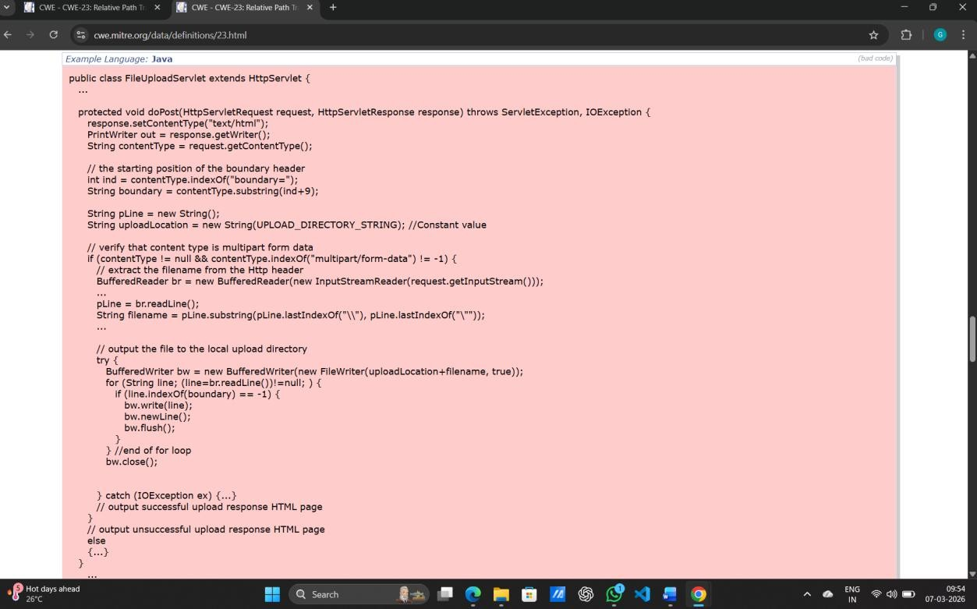
the attacker may be able to bypass that mechanism.

Recommandations:
- Avoid Direct User Input: The most effective way to prevent path traversal is to avoid passing user-supplied input directly to filesystem APIs.
- Use Indirect References: Instead of accepting a filename, use an index number or a unique ID that maps to a specific file in a server- side lookup table.
- Implement "Allow Lists": Only accept input that matches a strict list of permitted values or characters (e.g., alphanumeric only).
- Apply the Principle of Least Privilege: Ensure the application runs with the minimum necessary permissions so it cannot access
sensitive system files even if a traversal occurs.

- Vulnerability Name: Security Misconfiguration
CWE-16: Configration
OWASP Category: A01:2025- Security Misconfiguration
Description: It is missing appropriate security hardening across any part of the application stack or improperly configured permissions on cloud services. Unnecessary features are enabled or installed (e.g., unnecessary ports, services, pages, accounts, testing frameworks, or privileges). Default accounts and their passwords are still enabled and unchanged. A lack of central configuration for intercepting excessive error messages. Error handling reveals stack traces or other overly informative error messages to users.
Business Impact: Insecure settings can cause application crashes or allow attackers to trigger Denial of Service (DoS), preventing customers from reaching services and resulting in lost revenue.

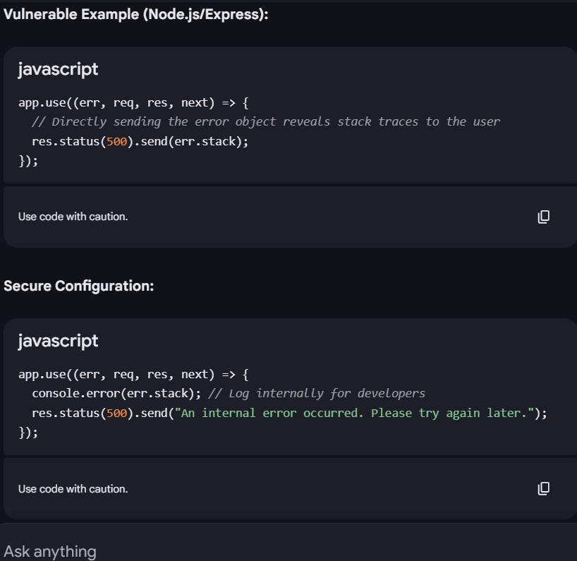

Recommadations:
  - Automate Hardening: Develop a repeatable hardening process to deploy environments that are appropriately locked down. Use
automation to ensure development, QA, and production environments are configured identically.
  - Maintain a Minimal Platform: Remove or do not install unused
features, components, frameworks, documentation, and samples to reduce the attack surface.
  - Enforce Least Privilege: Implement strict access controls and grant users only the minimum permissions necessary for their roles.

- Vulnerability Name: Software Supply Chain Failures

CWE-447: Use of Obsolete Function

CWE-1021: A03:2025 - Software Supply Chain Failures

Description: A UI function for a security feature appears to be supported and gives feedback to the user that suggests that it is supported, but the underlying functionality is not implemented.

Business Impact: CWE-447 occurs when a user interface displays features that are not actually implemented or supported by the system. This can confuse users and lead to frustration when they try to use non-functional options. As a result, user trust in the
application may decrease, and organizations may receive more support requests from users reporting these issues. Over time, this can reduce productivity, increase maintenance efforts, and
negatively affect the company’s reputation.
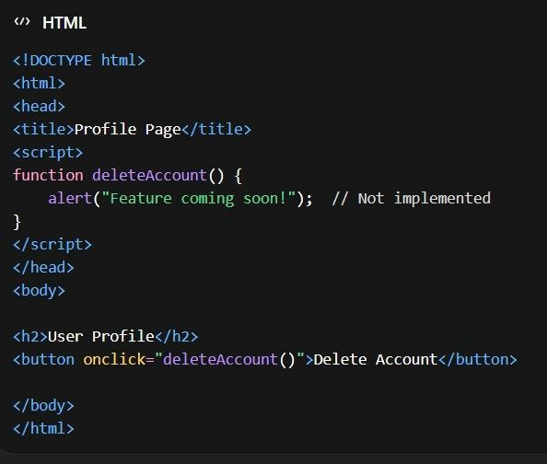

Recommendation:
Applications should avoid displaying features in the user interface that are not fully implemented or supported. Developers should

either remove such features from the UI or clearly disable them until they are completely developed and tested. Proper validation should also be implemented to ensure that unsupported functions cannot be triggered from the frontend or backend. Regular code reviews and UI testing should be conducted to identify incomplete features before deployment. This helps improve user experience, maintain application reliability, and prevent potential security risks.

- Vulnerability Name: Cryptographic Failures
CWE-331: Insufficient Entropy
OWASP Category: A04:2025- Cryptographic Failures

Description: The product uses an algorithm or scheme that produces insufficient entropy, leaving patterns or clusters of values that are more likely to occur than others.
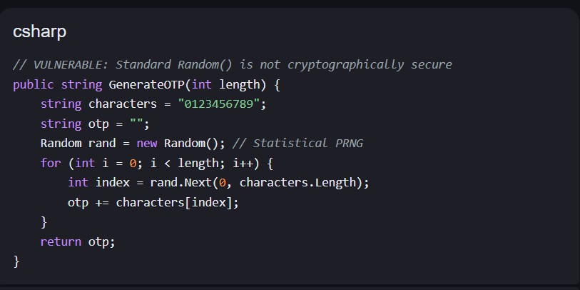
Business Impact: An attacker could guess the random numbers generated and could gain unauthorized access to a system if the random numbers are used for authentication and authorization.

Recommandations:
  - Eliminate Predictable Seeding:

    - Never seed an RNG with easily guessable data such as the system clock, process IDs, or hardware serial numbers.Modern CSPRNG APIs typically handle seeding automatically using OS- level entropy; avoid manual seeding unless using a high- entropy source.

Increase Output Length (Bit Size):
    - Ensure the generated value has enough bits of entropy to prevent brute-force attacks.

Avoid Hard-Coded Secret Values:
    - Do not use hard-coded salts, initialization vectors (IVs), or keys.Ensure these values are unique and randomly generated for every operation.

- Vulnerability Name: Injection

CWE- 114: Process Control

OWASP Category: A05:2025- Injection

Description: Process control vulnerabilities of the first type occur when either datum enters the application from an untrusted source and the data is used as part of a string representing a command that is executed by the application. By executing the command, the
application gives an attacker a privilege or capability that the attacker would not otherwise have.
Business Impact: Exploitation can lead to unauthorized code
execution that crashes services or halts production lines, resulting in significant revenue loss and missed delivery deadlines.

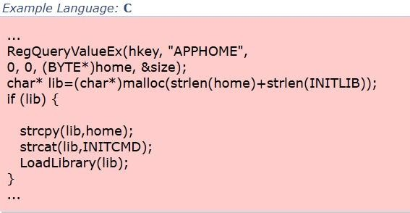

Recommandations:
Specify Absolute Paths: Always use the absolute path when loading libraries or executing external programs.
Bad: System.loadLibrary("helper.dll"); (Searches system paths which an attacker might influence).
Good: System.load("C:\\App\\libs\\helper.dll"); (Directly targets the intended file).
Use Hardcoded Paths: Whenever possible, hardcode the paths to required libraries and executables within the application to prevent them from being influenced by external configuration files or registry keys.

- Vulnerability Name: Insecure Design
CWE- 501: Trust Boundary Violation
OWASP Category: A06:2025- Insecure Design
Description: A trust boundary can be thought of as line drawn through a program. On one side of the line, data is untrusted. On the other side of the line, data is assumed to be trustworthy. The purpose of validation logic is to allow data to safely cross the trust boundary - to move from untrusted to
trusted. A trust boundary violation occurs when a program blurs the line between what is trusted and what is untrusted. By combining trusted and

untrusted data in the same data structure, it becomes easier for programmers to mistakenly trust unvalidated data.

Business Impact:
- Unauthorized Code Execution: Attackers can exploit this to execute arbitrary commands with the privileges of the current user,
potentially leading to a complete system compromise.
- Loss of Confidentiality: Sensitive information, such as administrator passwords or private encryption keys, can be fully divulged to an
attacker.

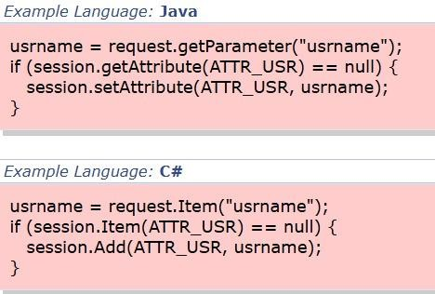

Recommandations:
- Establish Clear Trust Boundaries: Explicitly define which parts of your application and data structures are "trusted" versus "untrusted".
- Perform Strict Input Validation: Always validate data before storing it in a session or using it in a trusted context.
- Allow-list Validation: Compare input against a list of known-good values or patterns (e.g., regex) and reject everything else.

- Plausibility Checks: Integrate checks at every tier (frontend to backend) to ensure the data makes sense for its intended use.

- Vulnerability Name: Authentication Failures
CWE- 384 :Session Fixation
OWASP Category: A07:2025 - Authentication Failures
Description: Authenticating a user, or otherwise establishing a new user session, without invalidating any existing session identifier gives an attacker the opportunity to steal authenticated sessions.
Business Impact: Session Fixation occurs when an attacker forces a user to use a known session ID, allowing the attacker to hijack the session after the user logs in. This can lead to unauthorized access to user accounts and sensitive information. As a result, organizations may experience data breaches, financial loss, and misuse of user
accounts. It can also damage the company’s reputation and reduce customer trust in the system.
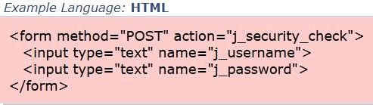

Recommendation:
To prevent session fixation attacks, applications should generate a new session ID after a user successfully logs in and invalidate any existing session IDs. Secure session management practices such as using strong random session IDs, HTTPS encryption, and proper session timeout should be implemented. Developers should also
ensure that session IDs are not exposed in URLs or stored insecurely.

Regular security testing and monitoring can help detect and prevent session-related vulnerabilities.

- Vulnerability Name: Software or Data Integrity Failures
CWE- 426: Untrusted Search Path
OWASP Category: A08:2025- Software or Data Integrity Failures
Description: This might allow attackers to execute their own programs, access unauthorized data files, or modify configuration in unexpected ways. If the product uses a search path to locate critical resources such as programs, then an attacker could modify that search path to point to a malicious program, which the targeted product would
then execute. The problem extends to any type of critical resource that the product trusts.
Business Impact: The program could be redirected to the wrong files, potentially triggering a crash or hang when the targeted file is too large or does not have the expected format.
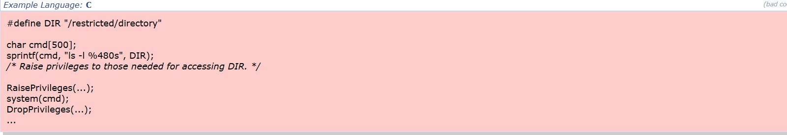

Recommandations:
- Sanitize Environment Variables: Before calling external commands, clear or hard-code the PATH, LD_LIBRARY_PATH, and other search- related variables to known-safe values.
- Avoid Dangerous Search Functions: In C/C++, use functions like execl() or execv() which require explicit paths, rather
than system(), which relies on the shell's untrusted search path.
- Secure Service Executables (Windows): Ensure all service paths are enclosed in double quotes if they contain spaces to prevent the "Unquoted Service Path" variant of this vulnerability.

G. Vulnerability Name: Security Logging and Alerting Failures
CWE- 778: Insufficient Logging
OWASP Category: A09:2025 - Security Logging and Alerting Failures
Description: When a security-critical event occurs, the product
either does not record the event or omits important details about the event when logging it.
Business Impact: Insufficient logging occurs when a system does not properly record important events such as user activities, errors, or security incidents. This makes it difficult for organizations to detect and investigate security attacks or system failures. Without proper logs, identifying the source of a problem or unauthorized
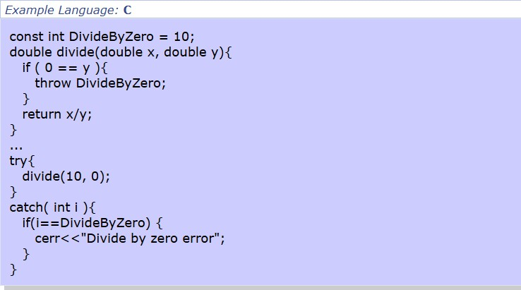
access becomes challenging. This can lead to data breaches, operational disruptions, financial losses, and damage to the organization’s reputation.

Recommendation: Organizations should implement proper logging mechanisms to record important system events such as user logins, access attempts, errors, and security-related activities. Logs should be detailed, securely stored, and regularly monitored to detect suspicious behavior. Access to logs should be restricted to
authorized personnel, and logs should be protected from

modification or deletion. Regular audits and automated monitoring tools should also be used to quickly identify and respond to security incidents.
- Vulnerability Name: Mishandling of Exceptional Conditions
CWE – 36G: Divide By Zero
OWASP Category: A10:2025- Mishandling of Exceptional Conditions
Descriptions: This weakness typically occurs when an unexpected value is provided to the product, or if an error occurs that is not properly detected. It frequently occurs in calculations involving physical dimensions such as size, length, width, and height.
Business Impact: This weakness typically occurs when an unexpected value is provided to the product, or if an error occurs that is not properly detected. It frequently occurs in calculations involving physical dimensions such as size, length, width, and height.


Recommandations:
  - Input Sanitization: For user-provided data, use "allow-lists" or range checks to ensure the value falls within a safe, non-zero interval.

  - Check Collection Sizes: When calculating averages or percentages based on the count of items in a list, verify the collection is not

STAGE-2
TITLE: Zero Trust Network Access (ZTNA) with Zscaler: Securing User-to-Application Connectivity.

Overview:
Nessus is a vulnerability scanning tool created by Tenable, Inc.. It functions as a remote scanner, which means it can analyse systems without needing to be installed directly on the target machine. The tool works by sending multiple types of probes to the target system to detect potential security weaknesses. These probes may include network packets, operating system commands, and requests sent to applications. Nessus operates using a plugin-based framework. Plugins are small programs designed to detect particular security vulnerabilities. More than 1,200 plugins are available in Nessus, enabling it to identify a wide range of issues across operating systems, software applications, and network devices. When a scan begins, Nessus first uses discovery plugins to determine the operating system and the services running on the target host. After identifying this information, it executes multiple plugins that test the system for possible vulnerabilities. For every vulnerability detected, Nessus generates a detailed report that includes the severity level, instructions to reproduce the issue, and
recommended steps to fix or mitigate the problem. Nessus can scan
different types of targets, such as individual computers, entire networks, and web applications. It also allows users to scan specific ports and
services when required. Scans can be performed manually or scheduled to run automatically at specific times.

Working Process of Nessus:
The following steps explain how Nessus performs a vulnerability scan:
- Nessus establishes a connection with the target system using protocols such as TCP, UDP, and ICMP.
- It sends multiple probes to identify the operating system and active services running on the host.
- The scanner then executes various plugins to check for known vulnerabilities.

- After completing the scan, Nessus generates a report that outlines
the detected vulnerabilities, their severity levels, reproduction steps, and possible remediation methods.
Nessus is widely used by cybersecurity professionals to detect and fix vulnerabilities within networks. Its ease of use and detailed reporting features help organizations prioritize and address security issues effectively.

Advantages of Using Nessus:
  - Wide vulnerability detection: With more than 1,200 plugins, Nessus can identify numerous vulnerabilities across operating systems, applications, and network devices.
  - User-friendly interface: The tool provides an intuitive interface that simplifies the configuration and execution of scans.
  - Detailed reporting: Nessus produces comprehensive reports describing vulnerability severity, reproduction procedures, and remediation steps.
  - Scalability: It can scan various targets including individual hosts, full networks, and web applications.
  - Flexible scanning: Users can run scans manually or schedule them to run automatically.
Overall, Nessus is a powerful security scanning solution that helps organizations strengthen their network security. It serves as an important tool for cybersecurity professionals aiming to identify and resolve system vulnerabilities.

Target Website: http://testaspnet.vulnweb.com
Target IP address: 44.228.249.3

List of Vulnerability Name:

S.NO | Vulnerability Name | Severity | Plugins
1. | Nessus SYN scanner | Port scanners | 11219
2. | Additional DNS Hostnames | General | 46180

3. | Nessus Scan Information | Settings | 19506
4. | OS Fingerprints Detected | General | 209654
5. | Remote Services Not Using Post-Quantum Ciphers | General | 277650
6. | Shor's Harvest Now Decrypt Later | General | 298387
7. | SSL Root Certification Authority Certificate Information | General | 94761
8. | TLS Version 1.2 Protocol Detection | Service detection | 136318

Report:
- Vulnerability Name: Nessus SYN scanner
Severity: Port scanners
Plugin ID: 11219 Port: 80 / TCP

Description:

This plugin is a SYN 'half-open' port scanner. It shall be reasonably quick even against a firewalled target.
Note that SYN scans are less intrusive than TCP (full connect) scans against broken services, but they might cause problems for less robust firewalls and also leave unclosed connections on the remote target, if the network is loaded.

Solution:

Protect your target with an IP filter.

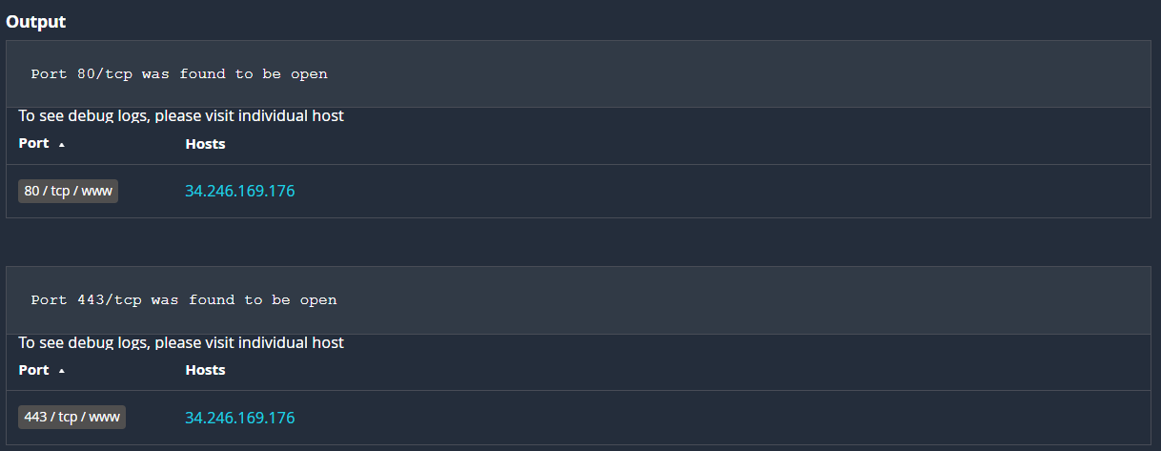

2.Vulnerability Name: Additional DNS Hostnames

Severity: General

Plugin ID: 46180

Port: 80 / TCP

Description:
Hostnames different from the current hostname have been collected by miscellaneous plugins. Nessus has generated a list of hostnames that point to the remote host. Note that these are only the alternate hostnames for vhosts discovered on a web server.
Different web servers may be hosted on name-based virtual hosts.

Solution:

If you want to test them, re-scan using the special vhost syntax, such as : www.example.com[192.0.32.10]

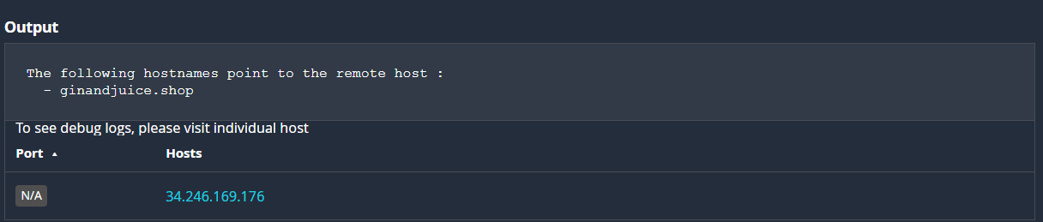

3.Vulnerability Name: Nessus Scan Information
Severity: Settings Plugin ID: 19506 Port: 80 / TCP

Description:
This plugin displays, for each tested host, information about the scan itself :
- The version of the plugin set.
- The type of scanner (Nessus or Nessus Home).
- The version of the Nessus Engine.
- The port scanner(s) used.
- The port range scanned.
- The ping round trip time
- Whether credentialed or third-party patch management checks are possible.
- Whether the display of superseded patches is enabled
- The date of the scan.
- The duration of the scan.
- The number of hosts scanned in parallel.
- The number of checks done in parallel.

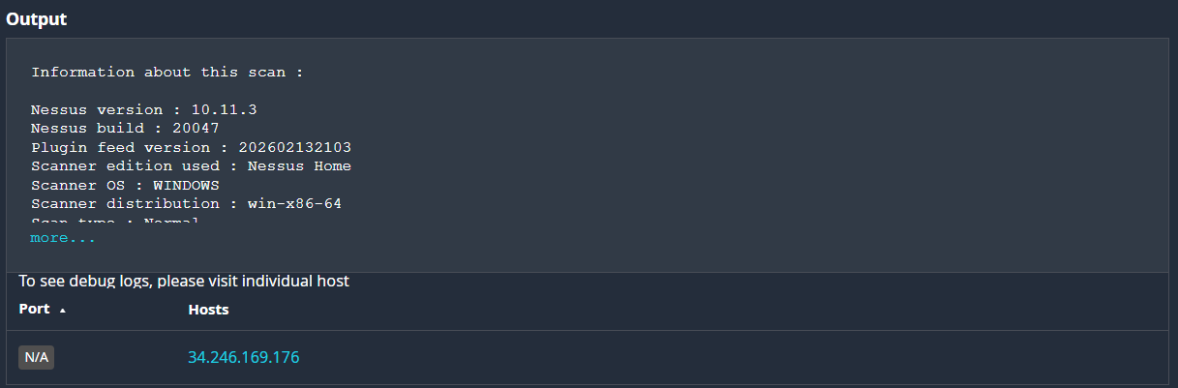
4.Vulnerabilitty Name: OS Fingerprints Detected
Severity: General Plugin ID: 209654 Port: 80 / TCP

Description:

Using a combination of remote probes (TCP/IP, SMB, HTTP, NTP, SNMP, etc), it was possible to gather one or more fingerprints from the remote system. While the highest-confidence result was reported in plugin 11936, “OS Identification”, the complete set of fingerprints detected are reported here.

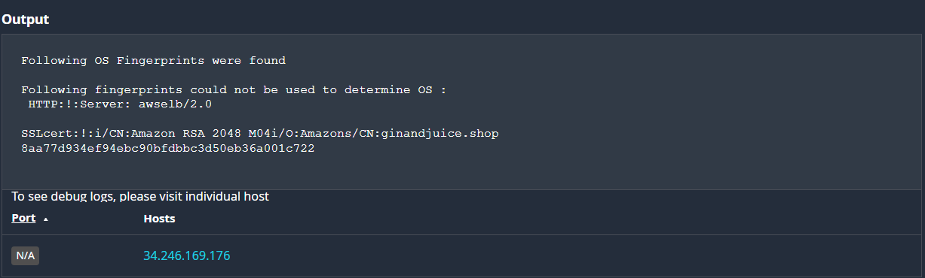

5.Vulnerability Name: Remote Services Not Using Post-Quantum Ciphers

Severity: General
Plugin ID: 277650
Port: 80 / TCP

Description:

The remote service is not configured to use post-quantum cryptographic ciphers. As quantum computing advances, traditional encryption algorithms (RSA, ECC) may become vulnerable to attacks. Without post-quantum algorithms, encrypted communication could be compromised in the future.

Output:

Remote service was detected using classical cryptographic ciphers only.67
Example: TLS handshake supported RSA and ECDSA but no post-quantum ciphers.

Solution:

Upgrade the cryptographic libraries and configurations to support post-quantum algorithms (such as CRYSTALS-Kyber, Dilithium, or other NIST-approved PQC standards). Ensure compatibility with client systems before deployment.

Risk Factor:

General – Currently secure against classical attacks, but vulnerable to future quantum-based threats.

6.Vulnerability Name: Shor's Harvest Now Decrypt Later
Severity: General Plugin ID: 298387 Port: 80 / TCP

Description:

The remote service relies on classical cryptographic algorithms (RSA, ECC) that are vulnerable to quantum attacks. Using Shor’s algorithm, a sufficiently powerful quantum computer could break these algorithms. Attackers may harvest encrypted data now and decrypt it later once quantum computing becomes practical, exposing sensitive information.

Output:
Remote service supports only classical ciphers:
RSA key exchange
ECDSA certificates
No post-quantum cryptographic ciphers detected.

Solution:

Transition to Post-Quantum Cryptography (PQC) algorithms such as CRYSTALS-Kyber (key exchange) and Dilithium (digital signatures).

Implement hybrid cryptographic approaches combining classical and PQC ciphers.

Regularly update cryptographic libraries to align with NIST PQC standards.

Risk Factor:
General – Secure against classical attacks today, but vulnerable to Harvest Now, Decrypt Later quantum-based threats in the future.

7.Vulnerability Name: SSL Root Certification Authority Certificate Information
Severity: General Plugin ID: 94761 Port: 80 / TCP
Description:
The remote server's SSL certificate chain includes the following Root Certification Authority (CA). Details of the root certificate used are provided below. This is an informational finding and does not indicate a vulnerability.

Output:

Issuer: DigiCert Global Root CA
Subject: CN=DigiCert Global Root CA / O=DigiCert Inc
Serial Number: 08:3E:BA:F2:43:82:CE:20:C9:6D:19:53:11:97:3A:4C
Signature Algorithm: sha256RSA
Validity Period: 10 Nov 2006 to 10 Nov 2031

Attackers may steal session cookies through XSS and hijack user sessions.

Solution:
Informational only. No action is needed unless certificate trust issues are observed.

Risk Factor:
None – This is an informational finding about the SSL root certificate.

8.Vulnerability Name: TLS Version 1.2 Protocol Detection
Severity: Service detection.
Plugin ID: 136318
Port: 80 / TCP

Description:

The remote service supports the Transport Layer Security (TLS) 1.2 protocol. TLS 1.2 is widely used and considered secure, but newer versions like TLS 1.3 offer improved performance and security features. This finding is informational and confirms protocol support.

Output:

TLS 1.2 protocol successfully negotiated during handshake.
Cipher suite used: TLS_ECDHE_RSA_WITH_AES_256_GCM_SHA384
Server supports TLS extensions and secure renegotiation.

Solution:

No action required. However, consider enabling TLS 1.3 for enhanced security and performance.

Risk Factor:
None – This is an informational finding confirming TLS 1.2 support.

STAGE 3
TITLE: Zero Trust Network Access (ZTNA) with Zscaler: Securing User-to-Application Connectivity.

Zero Trust Network Access (ZTNA)
Zero Trust Network Access (ZTNA) is a modern cybersecurity model that enables secure remote access to an organization’s internal applications and data through strict access control rules. Unlike traditional Virtual Private Networks (VPNs), which often allow users to access the entire
network once connected, ZTNA follows the principle of “never trust, always verify.” This means users are granted access only to the specific
applications they require, and only after their identity and device security status are validated. ZTNA plays an essential role in modern security
infrastructures. It helps organizations move beyond the traditional “castle- and-moat” security model, where internal networks were considered safe while external networks were treated as untrusted. Instead, ZTNA hides internal resources from the public internet and creates direct, encrypted connections between users and applications. This significantly reduces the attack surface and prevents threats such as attackers moving laterally within a network after gaining initial access.

The ZTNA Access Cycle
The ZTNA access cycle is an ongoing process that verifies user identity, establishes secure communication channels, and enforces access policies whenever a request is made. The typical stages include:

User Request
A user from any location—such as an office, home, or public place— requests access to a particular internal application, for example an HR system, financial server, or internal development repository.

Identity and Device Authentication

Before granting access, the ZTNA system verifies the user’s identity using methods such as multi-factor authentication (MFA). It also evaluates the security condition of the device being used, ensuring that antivirus software is updated, the firewall is active, and the device has not been compromised.

Policy Validation
The system then checks predefined access policies to determine whether the specific user, using a particular device, is allowed to access the requested application at that time.

Secure Connection Creation
If the request meets policy requirements, the ZTNA system establishes a secure and encrypted micro-tunnel between the user’s device and the application. Importantly, the user gains access only to that application rather than the entire network.

Continuous Monitoring
Even after access is granted, the system continuously observes the session for unusual activity. If suspicious behavior or device changes are detected, the connection can be immediately terminated.

Logging and Analysis
All access attempts—both successful and unsuccessful—are recorded and analyzed. These logs support security audits, threat detection, and improvements in access policies.

Zscaler (Zscaler Internet Access / Zscaler Private Access)
Zscaler provides a cloud-native security platform that delivers its services entirely through the cloud, removing the need for traditional on-premises hardware such as VPN gateways.
For implementing ZTNA, Zscaler offers Zscaler Private Access (ZPA). This service enables smooth, identity-based access to private applications
without placing users directly on the organization’s internal network.

The ZPA architecture works on a simple idea: the application is effectively placed within the Zscaler cloud environment, and users connect to it
securely through that platform. To enable secure access, the system gathers information from several sources, including:

Identity Providers (IdP)
Services such as Microsoft Azure Active Directory, Okta, or Ping Identity
are used to authenticate and verify user identities.

Device Security Platforms
Security tools like CrowdStrike Falcon, Tanium, or Microsoft Defender for Endpoint help determine the health and security status of the user’s device.

Business Applications
These include internal web applications, file servers, and legacy systems hosted either in private data centers or public cloud environments such as Amazon Web Services or Microsoft Azure.

Zscaler App Connectors
App Connectors are lightweight software components installed within the organization’s data center or cloud infrastructure. They create outbound connections to the Zscaler cloud, ensuring that internal servers remain
hidden from the internet and are not directly exposed to external threats.

Policy Enforcement in Zscaler
Zscaler enforces security policies by analyzing several factors such as user identity, device condition, and application access. The main policy
mechanisms include:
  - Identity-Based Access – Access rules are defined using user identities and group memberships rather than relying on IP
addresses.
  - Application Segmentation – Users are allowed to access only the specific applications they require instead of entire network
segments.

  - Least Privilege Principle – Users are granted only the minimum permissions necessary to perform their tasks, reducing the risk of misuse or compromise.

The Zscaler ZTNA Cycle
The ZTNA cycle implemented through Zscaler applies Zero Trust principles in a practical environment using cloud infrastructure. The typical workflow includes the following stages:

User Authentication
When a user tries to access an internal application, they are redirected to the organization’s Identity Provider for authentication. Multi-Factor Authentication (MFA) is also applied to verify the user.

Device Security Validation
Zscaler integrates with endpoint security solutions to confirm that the user’s device meets organizational security requirements before granting access.

Policy Evaluation
The Zscaler cloud platform analyzes the access request and checks it against predefined security policies. It verifies whether the user, device, time, and location meet the criteria to access the requested application.

Creation of Secure Micro-Tunnel
Once the request is approved, Zscaler establishes an encrypted micro- tunnel between the user’s device and the target application through the Zscaler cloud.

Traffic Inspection (Optional)
For approved applications, Zscaler can optionally inspect traffic to detect malware or enforce data loss prevention (DLP) policies.

Activity Logging and Monitoring
All activities are recorded within the Zscaler cloud portal, enabling security teams to perform analysis, reporting, and compliance verification.

MISP Integration (Malware Information Sharing Platform)
While Zscaler primarily manages secure application access, its capabilities can be strengthened by integrating threat intelligence platforms such as

Malware Information Sharing Platform.
- Threat Intelligence Integration
MISP collects and distributes threat intelligence related to malicious IP addresses, domains, and URLs. These indicators of compromise (IOCs) can be integrated into Zscaler’s cloud platform.

Proactive Threat Blocking
If an authorized user attempts to connect to a malicious website identified through the MISP feed, Zscaler Internet Access can block the connection, preventing potential security incidents.

Improved Threat Visibility
Security analysts can correlate Zscaler activity logs with MISP intelligence data. If unusual behavior is detected, analysts can determine whether the destination domain or IP is linked to known cyber-attack campaigns.

College Network Infrastructure
The college network environment contains several components that increase its exposure to cyber threats, particularly with the expansion of remote learning and administrative access. The infrastructure includes:
  - Core routers and switches
  - Distribution routers and switches
  - Wireless access points
  - Firewalls and Intrusion Detection Systems (IDS)
  - Internal application servers hosting student systems, library services, research repositories, and administrative portals
  - A legacy VPN concentrator used by faculty and staff for remote connectivity

However, relying on traditional VPN technology introduces several limitations.

Limitations of the Current VPN Model
- Excessive Network Access
Once connected through VPN, a compromised device could potentially access and attack multiple internal systems.

Limited External Collaboration
Some research platforms must be accessed by external partners, but VPN access exposes too much of the network.

Poor User Experience
Legacy VPN systems can be slow and inefficient because all user traffic must pass through the university network.

Deploying ZTNA with Zscaler in the College Network
To implement ZTNA using Zscaler Private Access, the focus should shift from protecting the network to controlling access to applications.
The deployment plan may include the following steps:

Application Identification
List all internal applications such as ERP systems, library databases, research servers, and file-sharing platforms. Determine which applications currently rely on VPN access.

User Segmentation
Divide users into groups such as:
  - Students
  - Research faculty
  - Administrative staff
  - IT administrators
  - External collaborators
Each group should only access applications relevant to their role.

Deployment of App Connectors
Install Zscaler App Connector virtual machines within the campus data center. These connectors establish secure outbound connections to the Zscaler cloud while keeping internal servers hidden from the internet.

Identity Provider Integration
Integrate Zscaler with the university’s existing identity system, such as Microsoft Azure Active Directory, allowing authentication through existing credentials and MFA policies.

Access Policy Configuration
Define detailed access policies. For example:
Faculty members may access the ERP system only after MFA
authentication and only if their device meets security requirements.

Client Connector Deployment
Students, faculty, and staff install the Zscaler Client Connector on their devices. This client securely routes traffic to private applications through ZPA and internet traffic through ZIA.

Threat Intelligence in the ZTNA Environment
Threat intelligence improves security decisions by providing contextual insights into access requests.

Key Sources
- Zscaler cloud activity logs
- External threat intelligence platforms such as MISP
- Identity provider authentication logs

Applications of Threat Intelligence
  - Adaptive access control based on contextual risk
  - Detection of compromised user accounts
  - Blocking communication with malicious domains and servers

Incident Response in a ZTNA Model

Incident response becomes faster and more efficient in a Zero Trust architecture because access is tightly controlled.

Detection
Security teams identify suspicious behavior, such as abnormal data downloads from a server.

Containment
Administrators can immediately revoke the user’s access through the Zscaler management portal, preventing further connections.

Eradication
The compromised device is isolated and examined for malware by IT staff.

Recovery
Once the issue is resolved and credentials are reset, access can be safely restored.

Post-Incident Review
Security teams analyze logs to determine the cause of the breach and update policies to prevent similar incidents.

Benefits
  - Rapid containment through cloud controls
  - Prevention of lateral movement within the network
  - Detailed forensic logs for investigation
  - Improved regulatory compliance

Understanding the Zscaler ZPA Tool
Zscaler Private Access is a cloud-based solution designed to connect users directly to applications instead of exposing the entire network.
Key features include:
- Application-focused security – Policies are created based on applications rather than network segments.

- Hidden infrastructure – Internal servers remain invisible to the internet because App Connectors only create outbound
connections.
- Dark cloud architecture – Applications remain hidden until authentication and verification are completed.
- Improved user experience – The Zscaler Client Connector operates silently without the complexity of traditional VPNs.
- High scalability – Being cloud-based, the system can support thousands of users without requiring additional hardware.

Conclusion
This project explored the role of artificial intelligence in web security using
IBM QRadar across several stages.
The first stage introduced web application testing and highlighted the importance of identifying vulnerabilities to maintain secure online systems. This foundational knowledge supported the later stages of the project.
The second stage focused on analyzing vulnerability reports generated by Nessus, which helped identify potential security weaknesses and guided the implementation of effective remediation strategies.
The third stage examined the concept of Zero Trust Network Access and its implementation through Zscaler Private Access. This approach
demonstrated a transition from traditional VPN-based access models to
identity-based, application-level connectivity. By hiding internal resources and enforcing strict access policies, ZTNA significantly reduces the risk of cyberattacks and unauthorized access.
Overall, the project emphasized the importance of adopting modern security approaches to address the challenges posed by remote work environments and cloud technologies.

Topics Explored:
Data Collection and Aggregation, Standardization and Normalisation, Enrichment and Analysis, Sharing and Distribution, Integration with

Security Tools, Customization and Flexibility, Automation and Orchestration, Community Involvement, Incident Response Support, Threat Intelligence Feeds, Soc and Siem

Tools explored:
Nmap, Metasploit, Nessus, Kali Linux, OWASP ZAP, Burp Suite

